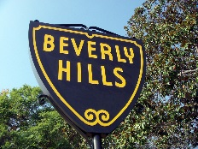
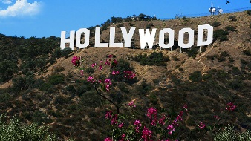
National Association of University Women 71st National Convention Los Angeles, California August 1-5, 2018
CONVENTION TOUR RESERVATION FORM Kenya Dennis, Chairperson

Name ____________________________________________________________
Address _________________________________________________________
City ______________________ State _____________ Zip Code ___________
Contact Information: Phone no.______________________________________
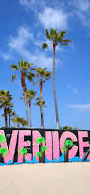
Email: ___________________________________________________________
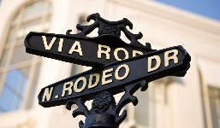
Pre-Convention Tour
AUGUST 1, 2018
Exclusive Grand Bus Tour of the City of Angels
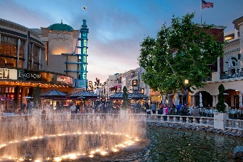
Highlights of tour include on and off: Hollywood Walk of Fame, Hollywood Sign, Kodak Theatre, Beaches, Sunset Strip, Beverly Hills, Rodeo Drive, Hollywood Bowl, LaBrea Tar Pits, CBS Television, LA County Museum of Art and Farmers Market/Grove, where you will have a 45 minute lunch break.
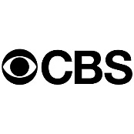
9:00 a.m.- 5:00 p.m.
$ 60.00 per person (Meal Not Included)

Number of seats: _______ X $ 60.00 per person = $ __________________
Make cashier’s check or money order payable to: NAUW
If paying via PayPal, Send form with a copy of the PayPal Confirmation receipt
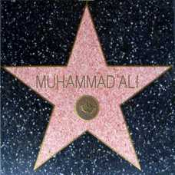
Please return this form with applicable fee(s) to:
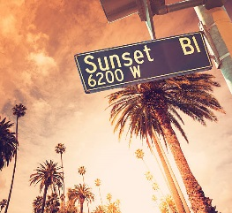
NAUW
P.O. Box 4025
Culver City 90231-4025
Deadline: June 1, 2018

"NAUW"
The 71st National Convention will feature the MANCAVE for our very important men attending this convention. The MANCAVE will be a place for our men to come and congregate while we are in our meetings. They can play cards, checkers, chess or dominos. They can watch ESPN together or just sit and talk while having a cool one! Let's make it happen for them. Invite your husband, son, nephew or any adult male to join you August 1-4,2018 so they can enjoy the sights of Manhattan Beach and the greater Los Angeles and surrounding areas. If interested, please complete the application below and return with your Registration Application.

THE NAUW MANCAVE AWAITS YOUR MALES!

NAUW MEMBER________________________________________________
MALE NAME___________________________________________________
PHONE :_______________________________________________________
EMAIL:________________________________________________________
COST: $ 25 per male - cashiers’ check or money order payable to NAUW
If paying via PayPal, Send form with a copy of the PayPal Confirmation receipt
Entitles you full access to the MANCAVE during scheduled times Aug. 1-4, 2018

Friday August 3rd
“Evening on your Own”
There are several options to choose from in the surrounding Manhattan Beach areas or we can arrange transportation to one of Los Angeles Night Spots. A transportation fee would apply and minimum of 20 people is required.
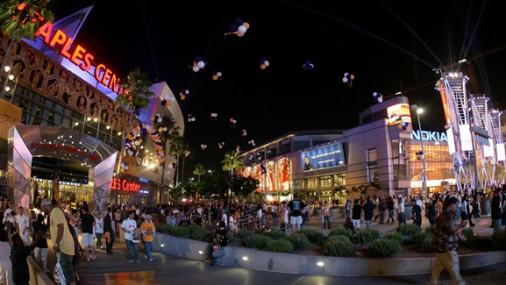
Option 1 - LA Live – (25.00.transportation fee)
L.A. LIVE is the sports and entertainment district that surrounds STAPLES Center and Microsoft Theater. The campus features sports and music venues, night clubs, Lucky Stripe bowling alley, Grammy museum, Regal Cinema movie theaters and several restaurants. L.A. LIVE is the premier destination for live entertainment in Downtown Los Angeles. Click on the link for more details https://www.lalive.com/
If Option 1 selected, check box and return with registration packet form.
If paid via paypal, write Paypal Conformation receipt number:_____________________
Option 2: Manhattan Beach/El Segundo Area – Walking distance or short uber/taxi ride from hotel.
Popular restaurants:
Houston’s, P.F. Chang China Bistro, McCormick & Schmicks, Grimaldi’s Coal Brick-Oven Pizza, Flemings, II Fornaio, Salt Creek Grille, Bristol Farms Café’
Manhattan Beach Village Mall- Brickworks Roasthouse Tin Roof Bistro, CPK, Corner Bakery Café, China Grill, Islands Restaurant, Joes’s Backyard BBQ.

Option 3: Must see Soul Food restaurants in the Los Angeles Area-Uber/Taxi ride
Roscoes Chicken and Waffles – Inglewood 5.8 miles from hotel
Dulans Restaurant – Inglewood 6.3 miles from hotel
M&M’s Soul Food – Inglewood 7.1 miles from hotel

